Ursula Gelis. WILPF. 'No-to-nuclear-weapons', Norway

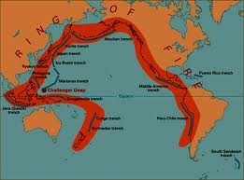
The safety myth - Japanese nuclear power plants touching the 'ring of fire'.

http://www.google.de/search?source=ig&hl=de&rlz=&q=ring+of+fire+in+the+pacific+ocean&oq=ring+of+fire+in+the+pacific&gs_l=igoogle.1.0.0i19j0i5i19l4.1107.9970.0.12854.31.25.2.3.3.0.271.3893.5j14j6.25.0...0.0...1ac.hLzVZYXhjVM

Emiko, you are a women's rights and peace activist, working for the abolition of nuclear weapons. What is your affiliation?

I am in charge of international relations for the New Japan Women's Association which is a women’s organization with 160,000 members all over the country. Our primary goal is to achieve the abolition of nuclear weapons. We are also working hard to promote gender equality and women's rights. Needless to say, we are active against US military bases in Japan. We work for peace and justice in general.

In addition to that we are focusing on relief operations after the Fukushima accident of March 2011. Support for women and mothers and children of this nuclear disaster is crucial.

Roughly a year later a lot of people from the Fukushima prefecture would like to return to their homes or closer to less contaminated zones?

I do not have the exact number of people with me now but not only citizens who lived close to the nuclear power plant escaped but many other families too were afraid of radiation and left the Fukushima prefecture.
I think there are thousands who fled.

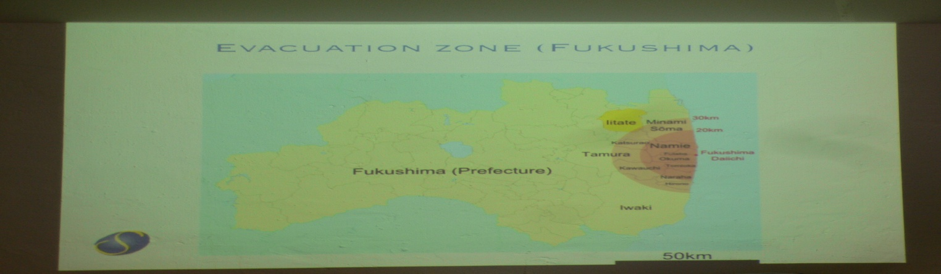
Photo: Ursula Gelis. Peace boat visit to Oslo, June 2012.

How about precautions in case of a nuclear power plant incident.
What was the policy in Japan concerning a potential accident?

Well, both the government and the electricity company, TEPCO, did not disclose enough information and issued warnings soon enough after the accident. It took them more than a day until the evacuation order was issued for the Fukushima people although they knew that the situation was very bad.
This delay in evacuation orders caused panic among the affected people. Useful information was not disclosed: for instance, officials did not admit that the meltdown was going on.

What was the knowledge of the average Japanese in terms of radiation danger in case of a nuclear power station incident?

Those of us being in the peace movement knew that the existence of nuclear power plants is dangerous in itself and also costly. Yet the Japanese government used every means to convince the local people to host nuclear power plants by saying that they are completely safe. We call this the safety myth.
All the 54 nuclear power plants are now undergoing regular check-ups and are not functioning. We call on the government not to restart them because they are simply not safe.
All the plants are located in coastal areas. The local communities are suffering from these structures. Especially older people have to pay the price of having these plants around. Younger people are moving to big cities. In order to increase the acceptance of a plant in a community a lot of governmental subsidies were offered.

Now we are witnessing an increase in the Japanese anti-nuclear power movement.

Yes, especially young people, many who have not been active in any movement at all before, now feel that they have been deceived by the government and they do not want any additional nuclear accident from happening.

Is it a change in mentality?

Absolutely. A very big change.

Normally, are not Japanese people very loyal to their government?

Yes, but they are not any more. In the meanwhile there is some confusion and dangerous tendencies among the public. Many people – especially in the Western part of Japan - are now supporting right wing positions. For example, the mayor of Osaka is calling for the change of Article 9 of the Japanese constitution.

Article 9 renounces war by saying that Japan will not start belligerent actions against other nations. It is a peace paragraph.

Yes. The mayor of Osaka even says that Article 9 is an obstacle for Japan to be an independent country.
Unfortunately the mayor is very popular and we in the peace movement are concerned that young people interested in politics perceive him as influential and might follow his course.

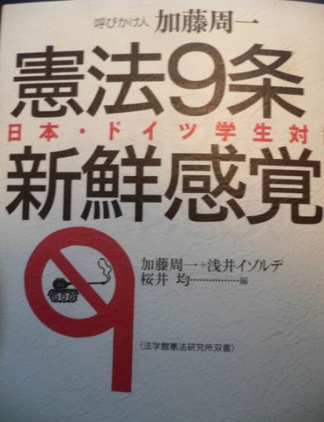
Photo: Ursula Gelis

Let's briefly turn to clean up measures in the Fukushima region. Plans to remove soil up to 5 centimeters are under discussion...

The government has to find a place for contaminated soil. No community will accept to be a dumping site for nuclear waste. There are local communities willing to take waste resulting from the Tsunami but not from the Fukushima accident.

What is TEPCO saying about the current level (May 2012) of radiation?

They say that it is decreasing but it does actually not. We are again demanding that TEPCO should disclose all the information it has.

It is really funny that before the Japanese agencies start making the information public, we can access relevant information from other countries through the internet.
Therefore the denial of the seriousness of the Fukushima accident could not be maintained for a long time.

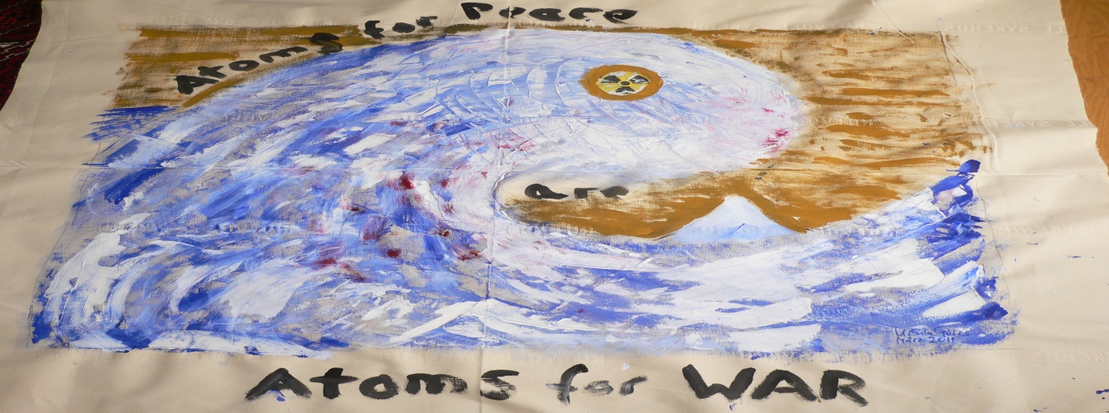
“Atoms for Peace are Atoms for War”. By Ursula Gelis. 2011

Which women organization is your strongest international partner?

It is the Women's International League for Peace and Freedom.

Interview with Emiko HIRANO. New Japan Women's Association (www.shinfujin.gr.jp) at th
Abolition 2000 annual meeting in Vienna, May 2012.

